English as a global communication language

In this exercise students learn about and discuss the pros and cons of English as a global language and relate this dilemma to the sustainable development goals.

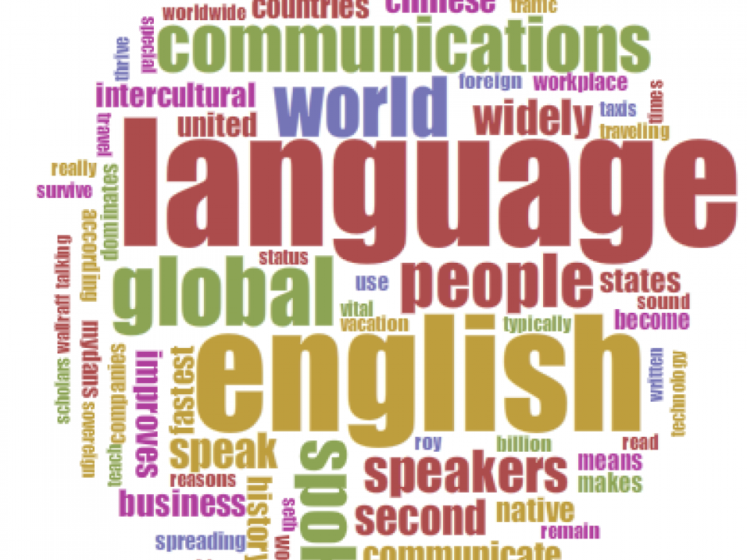

Kategori: Engelsk

Tid: 1 modul à 90 min.

**Formål:**  
This lesson is about the usefulness of having a global language to communicate with, when it could and should be used, and when it could be more appropriate to use another language. An interview with an activist talking about her campaigns and the language(s) she conducts them in will be used as a starting point to reflect on who is included and who is excluded when using English.

Students will reflect on the idea that whilst English as a global language is creating the ability to communicate across regions and countries, it also has its limitations. Language is a part of one’s history and culture, and speaking in another tongue necessarily makes one lose a little bit of that. Additionally, choosing to communicate in one language above others creates a global divide and a global elite; those who can and those who cannot.

A class discussion will link this theme to Denmark. A long time ago, state business in Denmark was conducted in German and Latin. What sort of inequality did that create? Why do they conduct business in Danish these days? Why did they make that change? What does that mean for democracy in Denmark? Students will link this idea to the sustainable development goals – specifically, goal 10: Reducing inequality within and among countries, and discuss the need to remember that language both includes and excludes, creating inequalities.

**Relation til bogen *Bliver verden bedre?:***  
"Forord" s.7  
"Hvad er udvikling" s.13-16

**Relation til FN's Verdensmål for bæredygtig udvikling:**  
[Verdensmål 10: Mindre ulighed](https://www.verdensmaalene.dk/maal/10) [2]

**Kernestof og centrale begreber:**  
- standardsprog og variation, herunder elementer af det engelske sprogs udvikling og det engelske sprog som globalt kommunikationssprog  
- historiske og aktuelle forhold i andre dele af den engelsktalende verden.  
- forstå forholdsvis komplekst mundtligt og skriftligt engelsk om almene og faglige emner  
- beherske et varieret ordforråd, som gør det muligt ubesværet at deltage i en samtale og diskussion på engelsk  
- give en længere, velstruktureret mundtlig og skriftlig fremstilling på flydende, korrekt engelsk af komplekse sagsforhold med forståelse for kommunikationssituationen

**Materialer:**  
Interview with Yasna  
Campaign materials using Bengali and English  
Excerpts from Grundtvig ‘Selected Educational Writings’ pp. 48-50

BBC News:  
[Celebrations for Bengali language](http://news.bbc.co.uk/2/hi/south_asia/2786795.stm) [3]

BBC News:  
[Bangladeshis mark Bengali language movement](http://news.bbc.co.uk/2/hi/south_asia/1833354.stm) [4]

BBC news:  
[Bengali should be UN language](http://news.bbc.co.uk/2/hi/south_asia/8425744.stm) [5]

UN article:  
[General Assembly hears appeal for Bangla to be made an official UN language](http://www.un.org/apps/news/story.asp?NewsID=36219#.WBMuj-y7qUl) [6]

Bogen [*Bliver verden bedre?*](https://www.verdensmaalene.dk/bog-bliver-verden-bedre) [7]

Denne øvelse er blevet lavet i forbindelse med Mellemfolkeligt Samvirkes kampagne På sporet af fællesskabet. Cases til disse øvelser handler om én af de unge aktivister der var med i kampagnen og det arbejde vedkommende laver i deres hjemland i forbindelse med verdensmålene for bæredygtig udvikling. Du kan læse mere om kampagnen [her](https://www.ms.dk/paasporet) [8], i pressemeddelelsen der ligger som PDF til download nederst på siden samt i [Materialesamling](http://verdensmaalene.dk/materialesamling) [9].

**Øvelse**

**LÆR**

The students read the online article:  
[People sacrificed their lives so you can speak your language today: The story behind International Mother Language Day 21st February](https://vocabridge.com/en/publications/international-mother-language-day) [10] (scroll down to find text), and watch the news report [Bangladeshis Revere Bengali Martyrs on "Language Movement Day"](https://www.youtube.com/watch?v=jQb_S9aUZ3Y) [11]. They then read the interview with Yasna from Bangladesh and look at the campaign materials she uses in her work (download PDF nederst på siden).

**GØR**

In small groups, the students discuss the following questions:  
- Which languages does Yasna speak?  
- Even though Bengali is her mother tongue, Yasna says that English has become necessary for her to use. Why is that?  
- Bangladeshis campaigned - and died - for the recognition of Bengali as an official language. Why was it so important to them?  
- In the article they write about ‘linguistic imperialism’. What is meant by that term?  
- Yasna says that both Bengali and English are used in official business in Bangladesh. Why do you think English is used as a language of communication in Bangladesh even though it is not an official language?  
- What are the benefits and disadvantages of using English as opposed to another language (for example, Bengali, the official language of Bangladesh)?  
- When official business is conducted in English, what does that mean for the people, who don’t speak English? What are the consequences?

After reading the small excerpt from Grundtvig’s writings about the need for official business to be conducted in Danish (download PDF nederst på siden), the small groups discuss the following questions about the use of German and Latin in the Danish government:  
- Grundtvig was a great advocate for conducting politics in Denmark in the Danish language instead of Latin and German. Why do you think that was?  
- What would happen if politics in Denmark were conducted in Latin today?  
- Why is state business conducted in Danish now? What does that mean for democracy?  
- Goal 10 of the Sustainable Development Goals is ‘reducing inequality within and among countries’. How do you think that the promotion of mother tongue in official business can contribute towards this goal?

Using the online articles and resources as a starting point (se under Materialer), the students then discuss the benefits and disadvantages of having a common global language.

**DEL**

Students continue their research about English as a global communication language, and relating their arguments to the Bangladeshi and Danish cases, students write an opinion piece about the benefits and disadvantages of English as a global communication language as homework.

**Source URL:** https://www.verdensmaalene.dk/undervisning/english-global-communication-language

**Links**  
[1] https://www.verdensmaalene.dk/print/undervisning/english-global-communication-language  
[2] https://www.verdensmaalene.dk/maal/10  
[3] http://news.bbc.co.uk/2/hi/south_asia/2786795.stm  
[4] http://news.bbc.co.uk/2/hi/south_asia/1833354.stm  
[5] http://news.bbc.co.uk/2/hi/south_asia/8425744.stm  
[6] http://www.un.org/apps/news/story.asp?NewsID=36219#.WBMuj-y7qUl  
[7] https://www.verdensmaalene.dk/bog-bliver-verden-bedre  
[8] https://www.ms.dk/paasporet  
[9] http://verdensmaalene.dk/materialesamling  
[10] https://vocabridge.com/en/publications/international-mother-language-day  
[11] https://www.youtube.com/watch?v=jQb_S9aUZ3Y  
[12] https://www.verdensmaalene.dk/sites/default/files/Interview%20with%20Yasna.pdf  
[13] https://www.verdensmaalene.dk/sites/default/files/Campaign%20material%201.pdf  
[14] https://www.verdensmaalene.dk/sites/default/files/Campaign%20material%202.pdf  
[15] https://www.verdensmaalene.dk/sites/default/files/paa_sporet_af_faellesskabet_pressemeddelelse_1.pdf  
[16] https://www.verdensmaalene.dk/sites/default/files/grundtvig_on_education_for_the_people_verdensmaal_engelsk.pdf